THE FUTURE OF FINANCE
A project report submitted in partial fulfillment of the requirements for the completion of
application development in
Bachelor of Technology
In
Computer Science and Engineering
By
P. Roshini (2511CS010711)
B. Rishit (2511CS010651)
D. Sai Shiva (2511CS010681)
S. Anjan Kumar (2511CS010666)

Under the guidance of
Mrs. P. Beersheba
Assistant/Associate Professor

Department of Computer Science & Engineering
MALLA REDDY UNIVERSITY, HYDERABAD
2026-2027



CERTIFICATE

This is to certify that this is the Application development lab record entitled “The Future of Finance”, submitted by P. ROSHINI (2511CS010711), B. RISHIT (2511CS010651), D. SAI SHIVA (2511CS010681), S. ANJAN KUMAR (2511CS010666), B. Tech II year I semester, Department of CSE during the year 2026-27. The results embodied in this report have not been submitted to any other university or institute for the award of any degree or diploma.

Internal Guide DEAN CSE
Mrs. P. Beersheba Dr. A.V.L.N. Sujith

External Examiner



DECLARATION
We declare that this project report titled The Future of Finance submitted in partial fulfillment of the degree of B. Tech in CSE is a record of original work carried out by us under the supervision of Mrs. P. Beersheba and has not formed the basis for the award of any other degree or diploma, in this or any other Institution or University. In keeping with the ethical practice in reporting scientific information, due acknowledgements have been made wherever the findings of others have been cited.

P. ROSHINI | (2511CS010711)
B. RISHIT | (2511CS010651)
D. SAI SHIVA | (2511CS010681)
S. ANJAN KUMAR | (2511CS010666)

ACKNOWLEDGEMENT
It gives us immense pleasure to express our profound gratitude to all those who extended their valuable support, encouragement, and guidance in the successful completion of this project.
First and foremost, we would like to express our heartfelt thanks to Dr. V. S. K. Reddy, Hon’ble Vice-Chancellor of our esteemed institution, for providing an excellent academic environment, necessary facilities, and constant encouragement that motivated us to pursue this project with enthusiasm and dedication. His inspiring leadership has always been a source of motivation for all students.
We are deeply indebted to Dr. A.V.L.N. Sujith, Dean, Department of Computer Science and Engineering, for his valuable support, expert advice, and continuous encouragement throughout the course of this project. His guidance and concern for students have greatly contributed to the successful completion of this work.
We wish to express our sincere appreciation and heartfelt gratitude to our project guide, Mrs. P. Beersheba, for her invaluable guidance, constructive suggestions, and constant supervision during every phase of this project. Her technical expertise, insightful feedback, and encouragement were instrumental in shaping this work and bringing it to completion.
We also extend our thanks to all the faculty members of the Department of Computer Science and Engineering for their cooperation and assistance whenever required.
Finally, we express our deep gratitude to our parents, friends, and well-wishers for their unwavering support, patience, and motivation throughout this journey. Their encouragement has been the driving force behind the successful completion of this project.

P. Roshini | (2511CS010711)
B. Rishit | (2511CS010651)
D. Sai Shiva | (2511CS010681)
S. Anjan Kumar | (2511CS010666)

ABSTRACT
In today’s digital world, financial literacy and effective money management are essential for making informed financial decisions. However, many individuals lack practical knowledge of budgeting, savings, investments, and financial planning. To address this challenge, the proposed project, “Future of Finance”, is an interactive web-based financial education and management platform designed to simplify financial learning and improve money management skills.
The platform integrates multiple features, including financial education, income and expense tracking, monthly budgeting, financial calculators, market analysis, financial news, and AIpowered assistance. It also introduces innovative interactive tools such as the Money Life Simulator, What If Analysis, Future Me, and EMI Smart Planner to help users understand financial decisions, compare alternative scenarios, plan payments, and visualize potential future financial outcomes.
The system is developed using HTML, CSS, and JavaScript, with Firebase for database services. Its user-friendly interface combines financial information, calculations, and interactive visualizations in a single platform.
The main objective of this project is to bridge the gap between theoretical financial knowledge and practical money management by promoting financial awareness, responsible spending, informed decision-making, and better financial planning.

TABLE OF CONTENTS
CERTIFICATE ......................................................................................................................................i
DECLARATION................................................................................................................................... ii
ACKNOWLEDGEMENT ...................................................................................................................iii
ABSTRACT ..........................................................................................................................................iv
TABLE OF CONTENTS ..................................................................................................................... v
LIST OF FIGURES ............................................................................................................................. vi
LIST OF TABLES .............................................................................................................................. vii
LIST OF ABBREVIATIONS ........................................................................................................... viii
CHAPTER – 1 INTRODUCTION ......................................................................................................1
1.1 Introduction ................................................................................................................................ 1
1.2 Problem Statement ..................................................................................................................... 1
1.3 Objectives of Project .................................................................................................................. 2
CHAPTER – 2 PROBLEM IDENTIFICATION ...............................................................................3
2.1 Existing System .......................................................................................................................... 3
2.2 Proposed System ........................................................................................................................ 4
CHAPTER – 3 REQUIREMENTS ..................................................................................................... 5
3.1 Software Requirements .............................................................................................................. 5
3.2 Hardware Requirements ............................................................................................................. 6
CHAPTER – 4 DESIGN AND IMPLEMENTATION ...................................................................... 7
4.1 Design ......................................................................................................................................7-8
4.2 Implementation ...........................................................................................................................9
4.3 Testing .........................................................................................................................................9
CHAPTER – 5 CODE ........................................................................................................................ 11
5.1 Source Code ........................................................................................................................ 11-19
5.2 Screenshots of Application ................................................................................................. 20-23
CHAPTER – 6 RESULTS & CONCLUSION ................................................................................. 24
6.1 Results ...................................................................................................................................... 24
6.2 Conclusion ................................................................................................................................25
REFERENCES ................................................................................................................................. 26

LIST OF FIGURES
FIGURE NO. | TITLE | PAGE NO.
Fig. 4.1 | System Architecture of the Future of Finance Platform | 7
Fig. 4.2 | Data Flow Diagram | 8
Fig.4.3 | Entity Relationship Diagram | 8
Fig. 5.1 | Home Page | 20
Fig. 5.2 | Integrated Financial Management Dashboard | 20
Fig. 5.3 | Market Analysis & Financial News | 21
Fig. 5.4 | Monthly Budget & Expense Tracking Dashboard | 21
Fig. 5.5 | Financial Learning & Interactive Quiz Module | 22
Fig. 5.6 | Future Lab – Interactive Financial Simulation | 22
Fig. 5.7 | Real-Time Institutional Market Analysis Dashboard | 23
Fig.5.8 | Real-Time Institutional Market Analysis Dashboard | 23

LIST OF TABLES
TABLE NO. | TITLE | PAGE NO.
3.1 | Software Requirements | 5
3.2 | Hardware Requirements | 6
4.1 | Test Scenarios and Expected Results | 10
6.1 | Objectives versus Outcomes | 24

LIST OF ABBREVIATIONS
ABBREVIATION | FULL FORM
AI | Artificial Intelligence
CSE | Computer Science and Engineering
API | Application Programming Interface
CRUD | Create, Read, Update, Delete
CSS | Cascading Style Sheets
ER | Entity Relationship
DFD | Data Flow Diagram
EMI | Equated Monthly Installment
FinTech | Financial Technology
HTML | HyperText Markup Language
SDK | Software Development Kit
SIP | Systematic Investment Plan
UI | User Interface

CHAPTER – 1

INTRODUCTION

Introduction
Finance plays a vital role in economic growth by supporting individuals, businesses, investments, and financial stability. In today’s rapidly evolving digital world, technology is transforming the financial industry through innovations such as Artificial Intelligence (AI), Financial Technology (FinTech), Blockchain, and Digital Banking. These advancements are making financial services smarter, faster, more accessible, and secure.
Modern financial platforms are changing the way people save, spend, invest, and manage their money. Future of Finance aims to combine financial knowledge with innovative technology by providing interactive financial education, budgeting tools, expense tracking, financial calculators, market insights, and intelligent assistance. The platform focuses on empowering individuals with practical financial knowledge, encouraging responsible money management, and supporting informed financial decisions for a better financial future.

1.2 Problem Statement
In today’s digital world, many individuals lack practical financial knowledge and face difficulties in managing income, expenses, savings, and investments effectively. Traditional financial education often focuses on theoretical concepts without providing sufficient opportunities for practical application. As a result, users may struggle with budgeting, financial planning, understanding market trends, managing EMI payments, and making informed financial decisions.
Existing financial platforms often provide separate services for learning, tracking, and planning, making it difficult for users to access everything in one place. Therefore, there is a need for an integrated, interactive, and user-friendly financial education and management platform that combines financial learning, expense tracking, budgeting, calculators, market insights, AI assistance, and financial simulations. The proposed Future of Finance platform aims to bridge this gap by improving financial literacy, encouraging responsible money management, and helping users develop better financial planning habits.

1.3 Objectives of Project
The main objective of Future of Finance is to develop an interactive and user-friendly webbased platform that improves financial literacy and simplifies personal money management through modern technology. The project aims to provide practical financial education, help users track income and expenses, manage monthly budgets, and make effective savings plans. It integrates financial calculators, market analysis, financial news, and AI-powered assistance to support informed financial decisions.
The platform also introduces innovative features such as EMI Smart Planner, Money Life Simulator, What If Analysis, and Future Me to help users understand financial scenarios, prepare for payments, and visualize potential future financial outcomes. Overall, the project focuses on bridging the gap between theoretical financial knowledge and practical application while encouraging responsible spending, regular savings, and better financial planning.

CHAPTER – 2

PROBLEM IDENTIFICATION

2.1 Existing System
The existing system for financial education and money management relies mainly on traditional methods such as manual budgeting, spreadsheets, separate financial applications, and online resources. These methods are often time-consuming and may lack proper integration between financial learning, expense tracking, savings, and investment planning. As a result, users may face difficulties in managing their finances effectively and making informed financial decisions.
Currently, there is no single platform that combines financial education, budgeting, financial calculators, market analysis, and interactive financial planning in one place. Users often need to switch between different applications to understand financial concepts, track expenses, calculate savings, and monitor market trends. This creates inconvenience and makes financial management less organized.
Even when digital financial tools are available, they may focus only on specific tasks and lack interactive learning, personalized assistance, or simulation-based features. There is also limited opportunity for users to explore financial situations through practical scenarios and understand the possible outcomes of their decisions.
Challenges in the Existing System:
- Lack of an integrated platform for financial learning and management.
- Difficulty in tracking income, expenses, and monthly budgets.
- Limited practical financial education and interactive learning.
- Dependence on multiple applications for financial planning.
- Lack of financial simulations and future financial projections.
- Difficulty in understanding market trends and making informed decisions.

2.2 Proposed System
The proposed system, Future of Finance, is a web-based financial education and management platform designed to simplify financial learning and personal money management. It provides a centralized environment where users can learn financial concepts, track income and expenses, manage monthly budgets, calculate savings and EMI plans, and explore market trends. The system integrates interactive financial learning, financial calculators, market analysis, financial news, and AI assistance to provide a practical and user-friendly experience.
Innovative features such as EMI Smart Planner, Money Life Simulator, What If Analysis, and Future Me help users understand financial scenarios, plan payments, and visualize possible future financial outcomes. The platform is developed using HTML, CSS, and JavaScript for the frontend, with Firebase for database services. Its interactive interface and integrated modules aim to make financial management more accessible, organized, and engaging.
Key Features of the Proposed System:
- Centralized platform for financial education and money management.
- Income and expense tracking with monthly budgeting.
- Financial calculators for savings, investments, and EMI planning.
- Interactive financial learning and quizzes.
- Market analysis and financial news updates.
- AI assistance for financial guidance.
- EMI Smart Planner for payment preparation.
- Money Life Simulator for exploring financial situations.
- What If Analysis for comparing possible financial decisions.
- Future Me for visualizing potential financial outcomes.

CHAPTER – 3

REQUIREMENTS

3.1 Software Requirements
The software requirements of the Future of Finance application describe the operating environment, development tools, and technologies needed to build and run the platform. The components used in the project are summarized in Table 3.1.
Table 3.1 Software Requirements
Component | Specification
Operating System | Windows / macOS / Linux
Frontend | HTML, CSS, JavaScript
Backend / Database | Firebase
Database Services | Firebase for data storage and management
Development Environment | Visual Studio Code
Web Browser | Google Chrome, Mozilla Firefox, Microsoft Edge
Financial Modules | Budgeting, Expense Tracking, Financial Calculators, Market  Analysis
AI Integration | AI Assistance for financial guidance
Visualization | Charts, Graphs, and Interactive Dashboards
Application Type | Web-Based Financial Education and Management System

Explanation:

The Future of Finance application is developed using HTML, CSS, and JavaScript to create an interactive and user-friendly frontend. Firebase is used for database services and data management. The platform integrates financial learning, income and expense tracking, monthly budgeting, financial calculators, market analysis, and financial news. AI assistance and interactive financial simulations are included to support users in understanding financial concepts and exploring different financial scenarios. The application can be accessed through modern web browsers on systems running Windows, macOS, or Linux.

3.2 Hardware Requirements
The hardware requirements of Future of Finance are minimal because it is a lightweight webbased application. The requirements are given in Table 3.2.
Table 3.2 Hardware Requirements
Component | Specification
Processor | Intel Core i3 or higher (recommended: Intel Core i5 or above)
RAM | Minimum 4 GB (recommended: 8 GB or higher)
Storage | 10 GB free disk space for development and project files
Graphics | Integrated graphics sufficient; no high-end GPU required
Network | Stable Wi-Fi or Ethernet connection
Input Devices | Standard keyboard and mouse
Display | Standard laptop or desktop display

Explanation:
The application can run efficiently on most modern laptops and desktop computers without requiring specialized hardware. A stable internet connection is required for accessing Firebase services and other online features. The system provides a convenient environment for learning financial concepts, managing budgets, performing calculations, and exploring financial insights.

CHAPTER – 4

DESIGN AND IMPLEMENTATION

4.1 Design
4.1.1 System Architecture
The system architecture diagram visually maps out the structure and interconnections of the “The Future of Finance” application, offering a streamlined representation of its core components. As shown in Fig. 4.1, users and administrators access the web interface, the application logic processes each request, and data is stored in and retrieved from the Firebase database, while the feature modules return results to a dashboard.
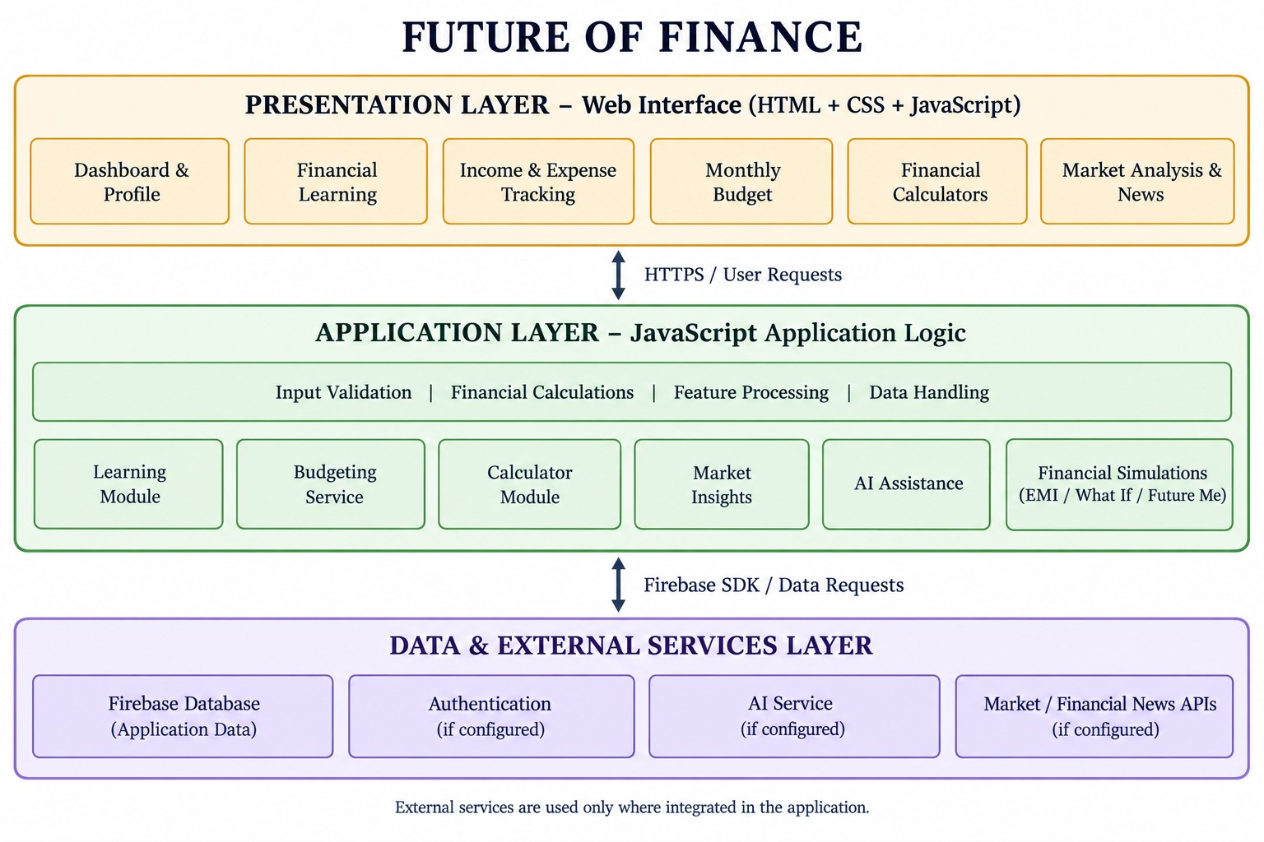
Fig. 4.1: System Architecture
4.1.2 Data Flow Diagram
The data flow of the platform is shown in Fig. 4.2. Navigation and login data enter the Future of Finance system, which provides the Learn Money, Spend Money / Budget, Calculators, and Market Analysis modules. These modules feed the financial planning and simulations component, and the results are presented on the dashboard as insights.
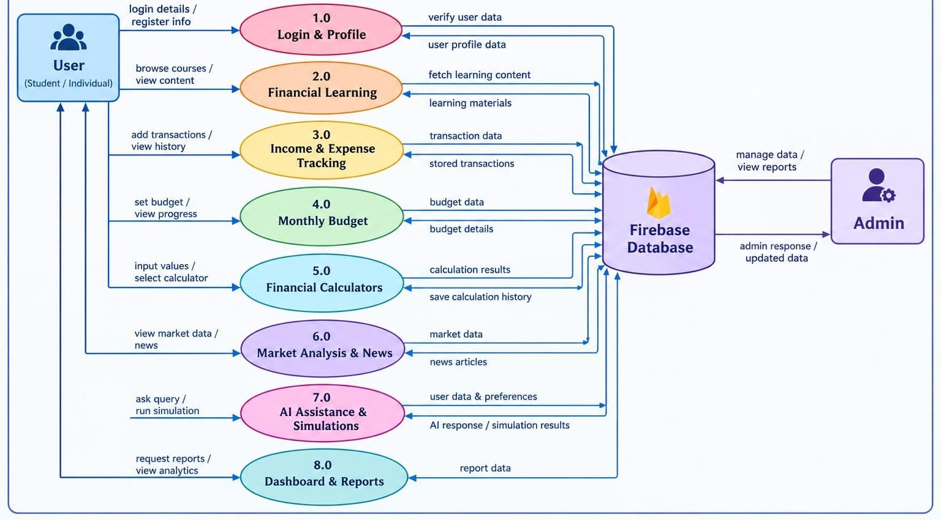

Fig. 4.2: Data Flow Diagram
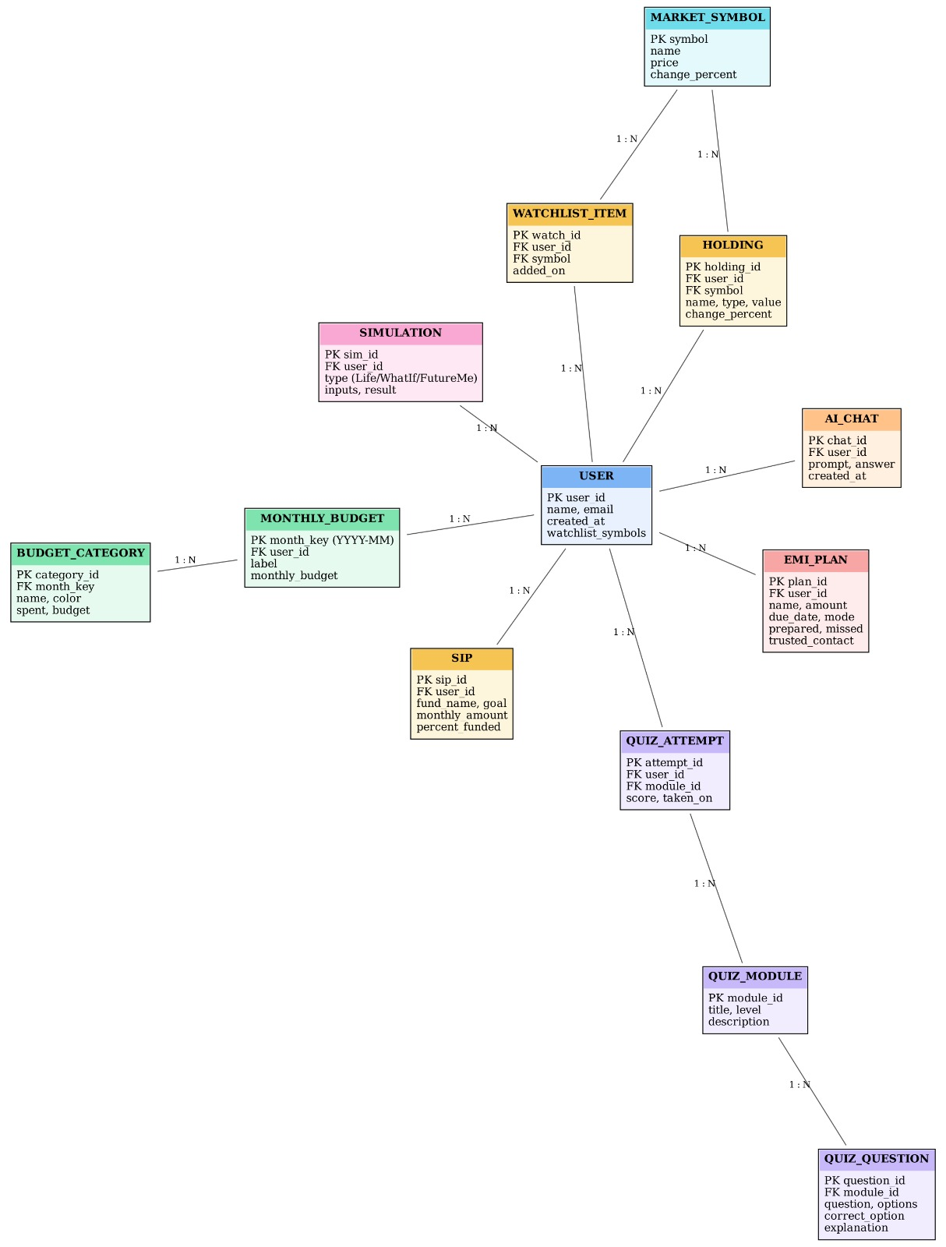
Fig. 4.3: Entity Relationship Diagram

4.2 Implementation
The Future of Finance system is implemented as a web-based financial education and management platform using HTML, CSS, and JavaScript for the frontend and Firebase for database services. The application provides a user-friendly interface through which users can access various financial features, including Learn Money, Earn Money, Spend Money, Monthly Budget, Financial Calculators, Market Analysis, and Financial News.
Interactive modules such as AI Assistance, EMI Smart Planner, Money Life Simulator, What If Analysis, and Future Me are integrated to provide practical financial learning and planning experiences. The system processes user inputs, performs financial calculations, organizes relevant information, and presents results through dashboards, charts, and visual summaries.
Firebase supports data storage and management, while the responsive interface allows users to access the platform through modern web browsers. Overall, the implementation focuses on combining financial knowledge, practical tools, and interactive technology in a single platform to promote financial literacy, responsible money management, and informed decision-making.

4.3 Testing
Testing is an important phase in the development of the Future of Finance system to ensure that all features function correctly, provide accurate results, and offer a smooth user experience. The application is tested to verify the functionality of financial learning modules, income and expense tracking, monthly budgeting, financial calculators, market analysis, and financial planning features. The testing process also checks user interactions, data storage and retrieval through Firebase, navigation between modules, and the accuracy of financial calculations.
Special attention is given to features such as EMI Smart Planner, Money Life Simulator, What If Analysis, and Future Me to ensure that inputs are processed correctly and results are displayed properly. Overall, testing helps identify errors, improve reliability, maintain data consistency, and ensure that the application meets its intended objectives of providing an effective and user-friendly financial education and management platform. The main test scenarios and their expected results are listed in Table 4.1.

Table 4.1 Test Scenarios and Expected Results

ID | Module | Test Scenario | Expected Result
TC01 | Navigation | Open each module from the navigation bar | The selected module opens without errors
TC02 | Learning | Open a lesson and attempt a quiz | Questions are shown and the result is displayed
TC03 | Budgeting | Add income and expense entries for a month | Entries are saved and totals are updated
TC04 | Budgeting | Change a category budget | Category breakdown and charts reflect the change
TC05 | Calculators | Enter values in the EMI and savings calculators | Calculated results are accurate
TC06 | Market Analysis | Select a stock or index symbol | Chart and market details are displayed
TC07 | Simulations | Run the Money Life Simulator and What If Analysis | Outcomes and comparisons are displayed correctly
TC08 | Simulations | Run Future Me with a saving amount and time horizon | Projected growth is shown
TC09 | AI Assistance | Ask a financial question in the  AI assistant | A relevant response is displayed
TC10 | Database | Save and reload user data through Firebase | Stored data is retrieved correctly

CHAPTER – 5

CODE

5.1 Source Code
This section presents the source code of the Future of Finance application. The main page of the application is implemented in a single HTML file.
index.html
<!DOCTYPE html>
<html lang="en">
<head>
<meta charset="UTF-8">
<meta name="viewport" content="width=device-width, initial-scale=1.0">
<title>Future of Finance — Markets, Portfolio &amp; Intelligence</title>
<link rel="preconnect" href="https://fonts.googleapis.com">
<link href="https://fonts.googleapis.com/css2?family=Fraunces:ital,opsz,wght@0,9..144,4 00;0,9..144,500;0,9..144,600;1,9..144,500&family=Inter:wght@400;500;600;700&fa m ily=JetBrains+Mono:wght@400;500;600;700&display=swap" rel="stylesheet">
<!-- Firebase Compat SDKs (ALL) -->
<script src="https://www.gstatic.com/firebasejs/10.12.2/firebase-app-compat.js"></script>
<script src="https://www.gstatic.com/firebasejs/10.12.2/firebase-auth-compat.js"></script>
<script src="https://www.gstatic.com/firebasejs/10.12.2/firebase-firestore-compat.js"></script>
<script src="https://www.gstatic.com/firebasejs/10.12.2/firebase-storage-compat.js"></script>
<script src="https://www.gstatic.com/firebasejs/10.12.2/firebase-database-compat.js"></script>
<script src="https://www.gstatic.com/firebasejs/10.12.2/firebase-functions-compat.js"></script>
<script src="https://www.gstatic.com/firebasejs/10.12.2/firebase-messaging-compat.js"></script>
<script src="https://www.gstatic.com/firebasejs/10.12.2/firebase-analytics-compat.js"></script>
<script src="https://www.gstatic.com/firebasejs/10.12.2/firebase-performance-compat.js"></script>
<script src="https://www.gstatic.com/firebasejs/10.12.2/firebase-remote-config-compat.js"></script>
<script src="https://www.gstatic.com/firebasejs/10.12.2/firebase-app-check-compat.js"></script>
<style>
:root {
--bg: #0A0F1D;
--bg-alt: #0D1425;
--surface: #121A2E;
--surface-2: #1A2338;
--surface-3: #232D48;
--border: rgba(255, 255, 255, 0.08);
--border-strong: rgba(255, 255, 255, 0.16);
--gold: #E8B84B;
--gold-soft: rgba(232, 184, 75, 0.13);
--gold-dim: #C99A38;
--mint: #34D399;
--mint-soft: rgba(52, 211, 153, 0.12);
--coral: #F87171;
--coral-soft: rgba(248, 113, 113, 0.12);
--blue: #3B82F6; --sky: #60A5FA;
--text: #F3F5F9;
--text-muted: #9AA3BE;
--text-dim: #5B6584;
--radius: 16px;
--radius-sm: 10px;
--serif: 'Fraunces', Georgia, serif;
--sans: 'Inter', -apple-system, sans-serif;
--mono: 'JetBrains Mono', ui-monospace, monospace;
--shadow-lg: 0 26px 60px -22px rgba(0, 0, 0, 0.6);
--shadow-sm: 0 10px 24px -14px rgba(0, 0, 0, 0.5);
} * {
box-sizing: border-box; margin: 0; padding: 0;
} html { scroll-behavior: smooth;
} body::before { content: ''; position: fixed; inset: 0; z-index: 0;
pointer-events: none;
} a {
color: inherit; text-decoration: none }
.container {
max-width: 1280px; margin: 0 auto; padding: 0 24px; } section { position: relative; z-index: 1; }
.hidden { display: none !important;
}
} /* Nav */ .nav { position: sticky; top: 0; z-index: 200; background: rgba(10, 15, 29, 0.85); backdrop-filter: blur(14px); border-bottom: 1px solid var(--border);
}
.nav-inner { max-width: 1280px; margin: 0 auto; padding: 0 24px; height: 80px; display: flex; align-items: center; justify-content: space-between;
} .brand { display: flex; align-items: center; gap: 12px; } align-items: center; gap: 2px; }
.nav-links button { background: none; border: none; color: var(--text-muted); font-size: 14.5px; font-weight: 500; padding: 9px 16px; border-radius: 8px; transition: .15s;
}
.nav-links button:hover { color: var(--text); background: var(--surface-2);
}
.nav-right { display: flex; align-items: center; gap: 10px;
}
.pill-live { display: flex; align-items: center; gap: 7px; font-size: 12.5px; font-weight: 600; color: var(--mint); background: var(--mint-soft); border: 1px solid rgba(52, 211, 153, 0.3); padding: 7px 14px; border-radius: 99px;
}
.pulse-dot { width: 7px; height: 7px; border-radius: 50%; background: var(--mint); animation: pulse 1.8s infinite;
} @keyframes pulse { 100% {
box-shadow: 0 0 0 0 rgba(52, 211, 153, 0);
}
} .btn { font-weight: 600; font-size: 14px; padding: 11px 20px; border-radius: 9px;
border: 1px solid transparent;
display: inline-flex; align-items: center; gap: 8px; transition: .15s; white-space: nowrap;
} .btn-gold { }
background: linear-gradient(180deg, var(--gold), var(--gold-dim)); color: #1a1408; }
.btn-gold:hover { filter: brightness(1.08); transform: translateY(-1px);
}
.btn-ghost { background: var(--surface); border-color: var(--border); color: var(--text);
}
.btn-ghost:hover { border-color: var(--border-strong); background: var(--surface-2);
}
.btn-sm { padding: 8px 15px; font-size: 13px;
}
/* Profile Dropdown & Logout Styling */
.profile-dropdown-wrap { position: relative; display: inline-block;
}
.user-chip { display: flex; align-items: center; gap: 9px; background: var(--surface); border: 1px solid var(--border); padding: 6px 14px 6px 6px; border-radius: 99px; cursor: pointer; user-select: none; transition: all 0.2s ease;
}
.user-chip:hover { border-color: var(--gold-dim); background: var(--surface-2);
.user-avatar { width: 28px; height: 28px; border-radius: 50%; background: linear- }
gradient(145deg, var(--gold), var(--gold-dim)); color: #1a1408; display: flex; align-items: center; justify-content: center; font-size: 12px; font-weight: 700; }
.user-chip-chevron { font-size: 9px; color: var(--text-muted); margin-left: 2px; transition: transform 0.2s; }
.user-chip.active .user-chip-chevron { transform: rotate(180deg); .profile-menu { position: absolute; top: calc(100% + 10px);
}
}
.profile-menu.show { display: block; }
@keyframes menuFadeIn { from { opacity: 0;
transform: translateY(-8px) scale(0.96);
} to { opacity: 1; transform: translateY(0) scale(1);
}
}
}
.profile-avatar-lg { width: 42px; height: 42px; border-radius: 50%;
background: linear-gradient(145deg, var(--gold), var(--gold-dim)); color: #1a1408; display: flex; align-items: center; justify-content: center; font-weight: 700; font-size: 17px;
box-shadow: 0 4px 12px rgba(232, 184, 75, 0.3);
.profile-info { flex: 1; overflow: hidden; }
.profile-info .name { font-size: 14.5px; font-weight: 600; color: var(--text); white-space: nowrap; overflow: hidden; text-overflow: ellipsis; }
.profile-info .badge { display: inline-flex; align-items: center; gap: 5px; font-size: 11px; color: var(--mint); font-family: var(--mono); margin-top: 2px; .profile-links {
} display: flex; flex-direction: column; gap: 2px; margin-bottom: 12px; }
.profile-link-item { display: flex; align-items: center; gap: 10px; padding: 9px 12px; border-radius: 8px; font-size: 13px; color: var(--text-muted); cursor: pointer; transition: all 0.15s; }
.profile-link-item:hover { background: var(--surface-2); color: var(--text); .profile-logout-btn { width: 100%; display: flex; align-items: center; justify-content: center; gap: 8px; padding: 10px; border-radius: 10px;
}
background: rgba(248, 113, 113, 0.12); border: 1px solid rgba(248, 113, 113, 0.3); color: var(--coral); font-weight: 600; font-size: 13.5px; transition: all 0.2s; cursor: pointer;
/* Real-time Financial Terminal Layout */
.term-grid-layout { display: grid; grid-template-columns: 1fr 310px; gap: 20px; align-items: stretch;
}
@media(max-width: 1100px) { .term-grid-layout { grid-template-columns: 1fr;
}
}
.symbol-selector-row { display: flex; gap: 6px; overflow-x: auto; padding-bottom: 8px; margin-bottom: 16px;
border-bottom: 1px solid var(--border);
} .sym-btn { padding: 6px 14px; font-size: 12px; font-family: var(--mono); font-weight: 600; border-radius: 8px; background: var(--surface-2); border: 1px solid var(--border); color: var(--text-muted); cursor: pointer; white-space: nowrap; transition: all 0.15s; }
.sym-btn:hover { border-color: var(--gold-dim); color: var(--text); }
.sym-btn.active { background: var(--gold-soft); color: var(--gold); border-color: var(--gold);
}
.term-live-badge { display: inline-flex; align-items: center; gap: 6px; padding: 5px 12px; border-radius: 99px; @keyframes flashRed { 0% { color: #F87171;
text-shadow: 0 0 12px rgba(248, 113, 113, 0.8);
} 100% { color: inherit; text-shadow: none;
}
} .orderbook-card { background: var(--surface-2); border: 1px solid var(--border); border-radius: 12px; padding: 16px; display: flex; flex-direction: column; gap: 14px; height: 100%; } .ob-head { display: flex; justify-content: space-between; align-items: center; font-family: var(--mono); font-size: 11px; letter-spacing: .06em; color: var(--text-dim); text-transform: uppercase; .ob-row { display: flex; justify-content: space-between; position: relative; padding: 3px 6px; border-radius: 4px; z-index: 1; } .ob-bar { position: absolute; top: 0; bottom: 0; right: 0; z-index: 0; opacity: 0.18; border-radius: 4px;
} max-height: 140px; overflow-y: auto; font-family: var(--mono); font-size: 11.5px;
} .tape-row { display: flex; justify-content: space-between; padding: 2px 4px;
border-bottom: 1px dashed rgba(255,255,255,0.05); }
.chart-container-relative { position: relative; width: 100%;
}
</head>
<body>
<!-- Ticker container -->
<div class="ticker">
<div class="ticker-wrap">
<div class="ticker-track" id="tickerRow"></div>
</div>
</div>
<nav class="nav">
<div class="nav-inner">
<div class="brand">
<div class="brand-mark"><svg width="19" height="19" viewBox="0 0 24 24" fill="none" stroke="#fff" stroke-width="2.4">
<path d="M3 17l6-6 4 4 8-8" />
<path d="M15 7h6v6" />
</svg></div>
<div>
<div class="brand-text">Future of Finance</div>
<div class="brand-sub">MARKETS · PORTFOLIO · INTELLIGENCE</div>
</div>
</div>
<div class="nav-links" id="navLinks">
<button data-target="#portfolio">Markets</button>
<button data-target="#portfolio">Portfolio</button>
<button data-target="#calculators">Calculators</button>
<button data-target="#charts">Charts</button>
<button data-target="#financeJourney">Money Journey</button>
<button data-target="#futureLab">Future Lab</button>
<button data-target="#newsroom">Newsroom</button>
</div>
<div class="nav-right"> <button class="hamburger" id="hamburger"><span></span><span></span><span></span></button> <span class="pill-live"><span class="pulse-dot"></span>Markets Open</span>
<div id="authArea"></div>
</div>
</div>
</nav>
<main>
<!-- HERO -->
<section class="hero" id="home">
<div class="container hero-grid">
<div>
<div class="eyebrow">ISSUE 07 · Q3 MARKET REVIEW</div>
<h1>The quiet <em>architecture</em><br>of modern wealth.</h1>
<p class="lead">A unified workspace for markets, portfolio and research — engineered with the discipline of institutional tools and the clarity of an editorial newsroom.</p> <div class="hero-cta"> <button class="btn btn-gold"
onclick="document.getElementById('portfolio').scrollIntoView({behavior:'smooth'})">O p en dashboard
→</button>
<button class="btn btn-ghost"
</div>
</div>
<div class="snap-card-big">
<div class="snap-head"><span>TODAY'S SNAPSHOT · <span id="snapTime"></span></span><span class="pulse-dot"></span></div> <div class="snap-2x2" id="snap2x2"></div>
</div>
</div>
</section>
<!-- FINANCE JOURNEY: CENTRAL FEATURE MAP -->
<section class="sec" id="financeJourney">
<div class="container">
<div class="sec-head">
<div>
<div class="eyebrow">YOUR MONEY JOURNEY</div>
<h2>Learn. Plan. Experience. Improve.</h2>
<p>All major Future of Finance capabilities organised around one simple journey
— from understanding money to visualising your future.</p>
</div>
</div>
<div class="journey-grid">
<div class="journey-card"><div class="journey-num">01</div><div class="journeyicon"> </div><h3>Learn Money</h3><p>Build financial knowledge through lessons and quizzes.</p><button class="btn btn-ghost btn-sm"
onclick="document.getElementById('learn').scrollIntoView({behavior:'smooth'})">Open </butto n></div>
<div class="journey-card"><div class="journey-num">02</div><div
class="journeyicon"> </div><h3>Earn Money</h3><p>Understand income, career earnings and ways
income can change a financial plan.</p><button class="btn btn-ghost btn-sm" onclick="openEarnMoney()">Explore</button></div>
<div class="journey-card"><div class="journey-num">04</div><div class="journeyicon"> </div><h3>Monthly Edit</h3><p>Edit monthly categories, budgets and actual spending.</p><button class="btn btn-ghost btn-sm" onclick="openMonthlyDashboard()">Open</button></div> <div class="journey-card"><div class="journey-num">05</div><div class="journeyicon"> </div><h3>Calculators</h3><p>Use SIP, EMI, retirement, lumpsum, tax and other planning tools.</p><button class="btn btn-ghost btn-sm" onclick="document.getElementById('calculators').scrollIntoView({behavior:'smooth'})"
>Open</ button></div>
<div class="journey-card"><div class="journey-num">06</div><div class="journeyicon"> </div><h3>Money News</h3><p>Read curated financial and market
coverage.</p><button class="btn btn-ghost btn-sm" onclick="document.getElementById('newsroom').scrollIntoView({behavior:'smooth'})">
Open</ button></div>
<div class="journey-card"><div class="journey-num">08</div><div class="journeyicon"> </div><h3>Quiz</h3><p>Test financial knowledge and learn from explanations.</p><button class="btn btn-ghost btn-sm"
onclick="document.getElementById('learn').scrollIntoView({behavior:'smooth'});setTim eout(()=
>document.getElementById('quizArea')?.scrollIntoView({behavior:'smooth'}),300)">Op en</butt on></div>
t(()=>document.getElementById('lifeSimCard')?.scrollIntoView({behavior:'smooth',bloc k:'center' }),300)">Try it</button></div>
<div class="journey-card"><div class="journey-num">10</div><div <div class="journey-card"><div class="journey-num">11</div><div class="journeyicon"> </div><h3>Future Me</h3><p>Visualise how regular saving can grow over a chosen time horizon.</p><button class="btn btn-gold btn-sm" onclick="document.getElementById('futureLab').scrollIntoView({behavior:'smooth'});se tTimeou
t(()=>document.getElementById('futureMeCard')?.scrollIntoView({behavior:'smooth',bl ock:'cen ter'}),300)">Try it</button></div>
</div>
</div>
</section>
<!-- NEWSROOM TEASER -->
<section class="sec" id="newsroom-teaser">
<div class="container">
<div class="sec-head">
<div>
<div class="eyebrow">THE NEWSROOM</div>
<h2>This week in markets</h2>
</div>
<button class="btn btn-ghost btn-sm" onclick="document.getElementById('newsroom').scrollIntoView({behavior:'smooth'})">
Al l coverage →</button>
</div>
<div class="teaser-grid">
<div class="cover-card">
<span class="cover-tag">Cover Story</span>
<h3>How compounding rebuilt a generation's balance sheet.</h3>
<p>Two decades of steady SIP inflows have reshaped Indian household portfolios
— a quiet revolution in patient capital, in charts.</p>
<div class="side-news-item"><span class="side-cat">Mutual Funds</span> <h4>SIP arithmetic, revisited: horizon vs. contribution.</h4><span class="meta">Yesterday ·
Analysis</span>
</div>
<div class="side-news-item"><span class="side-cat">Sector</span> <h4>Tech leaders extend gains on earnings visibility.</h4><span class="meta">2 days ago · Sector</span>
</div>
</div>
</div>
</div>
</section>
<!-- PORTFOLIO / DASHBOARD -->
<section class="sec" id="portfolio">
<div class="container">
<div class="sec-head">
<div>
<div class="eyebrow">YOUR WORKSPACE</div>
<h2>Portfolio, at a glance.</h2>
<p>Holdings, systematic plans and watchlist — organised the way portfolio managers read a book.</p>
</div>
<h3>Holdings &amp; Positions</h3>
<div class="sub" id="holdCount">4 instruments · ₹27,746 net</div> </div>
<span class="pill-live" style="padding:5px 12px;font-size:11.5px"><span class="pulse-dot"></span>Live</span>
</div>
<div class="tabs">
<button class="tab-btn active" data-tab="holdings" onclick="setPortTab('holdings')">Holdings</button> <button class="tab-btn" data-tab="sips" onclick="setPortTab('sips')">SIPs</button> <button class="tab-btn" data-tab="watchlist" onclick="setPortTab('watchlist')">Watchlist</button>
</div>
<div id="portTabContent"></div>
<div class="row-actions"> <button class="btn btn-ghost btn-sm"
onclick="gated(()=>showToast('Added to watchlist'),'add to your watchlist')()">+ Add watch</button>
<button class="btn btn-ghost btn-sm"
onclick="gated(()=>document.getElementById('charts').scrollIntoView({behavior:'smoo th'}),'open the live chart')()">Open chart</button>
</div>
</div>
<div class="card">
<div class="card-head">
<div>
<h3>Allocation &amp; performance</h3>
<div class="sub">30-day return: <span class="up">+4.62%</span></div>
</div>
<div class="editor-note">
<div class="lbl">Editor's Note</div>
<p>Your portfolio leans equity-heavy. Consider a debt tranche to smooth drawdowns before the earnings season.</p> </div>
</div>
</div>
</div>
</section>
<section class="sec" id="budget">
<div class="container">
<div class="sec-head">
<div>
<div class="eyebrow">THE LEDGER</div>
<h2>Spending, tracked.</h2>
<p>Every category, budgeted and visualised — so surprises show up before the statement does.</p>
</div>
<div style="display:flex; gap:10px; flex-wrap:wrap; align-items:center">
<select class="mb-select" id="mbMonthSelect"></select>
<button class="btn btn-gold btn-sm"
onclick="gated(openMonthlyDashboard,'open the full monthly dashboard')()">Calculate this month</button>
</div>
</div>
<div class="insight-box">
<div class="ic">✦</div>
<div>
<h4>AI Insight</h4>
</div>
<div class="budget-grid">
<div style="display:flex; flex-direction:column; gap:18px">
<div class="card">
<div class="mb-stat-row">
<div>
<div class="mb-stat-label">Total spent</div>
<div class="mb-stat-value" id="mbStatSpent">₹0</div>
</div>
<div class="mb-stat-divider"></div>
<div>
<div class="card-head" style="margin-bottom:0">
<h3 id="mbHighlightName">—</h3>
</div>
<div class="mb-over-pill" id="mbOverPill"></div>
</div>
<div class="mono" id="mbHighlightAmt" style="font-size:13px; color:var(-- text-muted); margin-bottom:16px">₹0 / ₹0</div>
<div class="donut-wrap" style="height:170px">
<div class="donut-ring" id="mbDonut" style="--hole:66%"></div>
<div class="donut-center">
<div class="amt" id="mbDonutTotal">₹0</div>
<div class="lbl">SPENT</div>
</div>
</div>
<div id="mbLegend"></div>
</div>
</div>
<div class="card">
<div class="card-head">
<h3>Category breakdown</h3>
</div>
<div id="mbCatList"></div>
</div>
</div>
</div> </section> function renderAIContext() { const body = document.getElementById('aiBody'); if (!body) return; const msg = state.loggedIn ? aiSectionMsgs.portfolio
const body = document.getElementById('aiBody'); if (body && body.children.length === 0) { renderAIContext();
}
}
function askGenkitQuick(promptText) {
document.getElementById('aiInput').value = promptText; aiAsk(); }
async function callGenkitAI(userQuery) { const userContext = { loggedIn: state.loggedIn, userName: state.userName || 'Investor', activeSection: state.portTab || 'portfolio', holdings: holdings ? holdings.map(h => ({ name: h.name, val: h.val, chg: h.chg })) : [], expenses: (mbStore && mbStore.months[mbStore.current]) ?
mbStore.months[mbStore.current].categories.map(c => ({ name: c.name, amt: `₹${c.spent.toLocaleString('en-IN')} / ₹${c.budget.toLocaleString('en-IN')}`, pct:
c.budget > 0 ? Math.round((c.spent / c.budget) * 100) : 0 })) : [], marketQuotes: { sensex: (tickerData && tickerData[0]) ? tickerData[0].v : '80,412.90', nifty: (snapData && snapData[0]) ? snapData[0].v : '24,586.20', usdInr:
(snapData && snapData[2]) ? snapData[2].v : '83.12'
}
};
if (isFirebaseConfigured && window.firebase && window.firebase.functions) { try {
const functions = firebase.functions();
const genkitChatFn = functions.httpsCallable('genkitChat'); const result = await genkitChatFn({ prompt: userQuery, userContext
}); if (result && result.data && result.data.answer) {
}
} catch (err) {
console.warn("Firebase Genkit Cloud Function call failed, trying local Genkit endpoint:", err.message);
}
}
// 2. Try Local Genkit AI Server endpoint (http://localhost:3400/api/genkit/chat) try {
if (response.ok) { const data = await response.json(); if (data && data.answer) { return data.answer;
}
}
} catch (err) {
console.warn("Local Genkit server fetch failed, using Genkit client engine:", err.message);
}
const lowerQ = userQuery.toLowerCase(); async function aiAsk() { const input = document.getElementById('aiInput'); if (!input) return; const q = input.value.trim(); if (!q) return;
const body = document.getElementById('aiBody'); if (!body) return; const }
renderAIContext();
</script>
</body>
</html>

5.2 Screenshots of Application
Dashboard

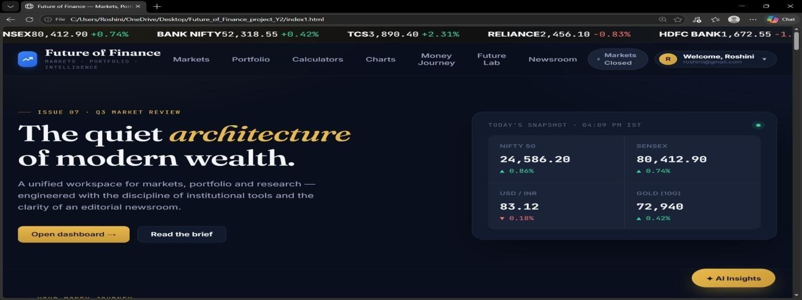

Fig. 5.1: Home Page
The homepage of “The Future of Finance” provides a user-friendly experience, featuring intuitive navigation and a visually appealing design, fostering a welcoming and efficient platform.

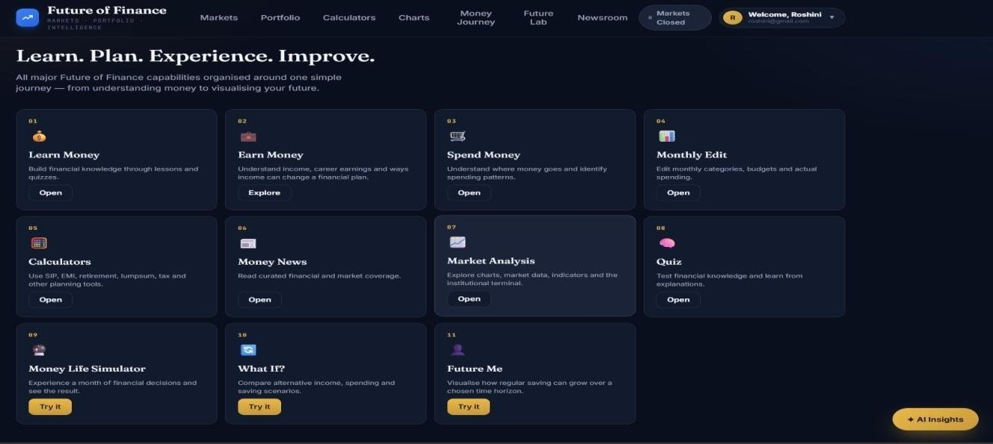

Fig. 5.2: Integrated Financial Management Dashboard
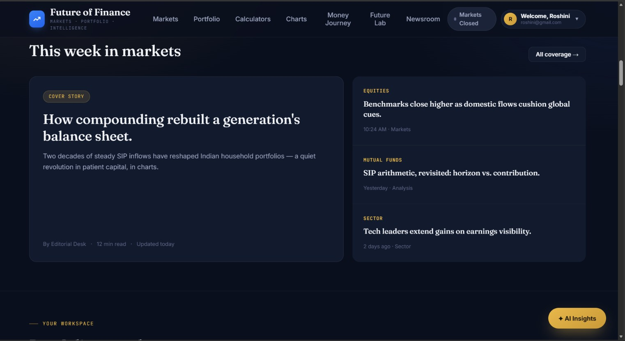

Fig. 5.3: Market Analysis & Financial News

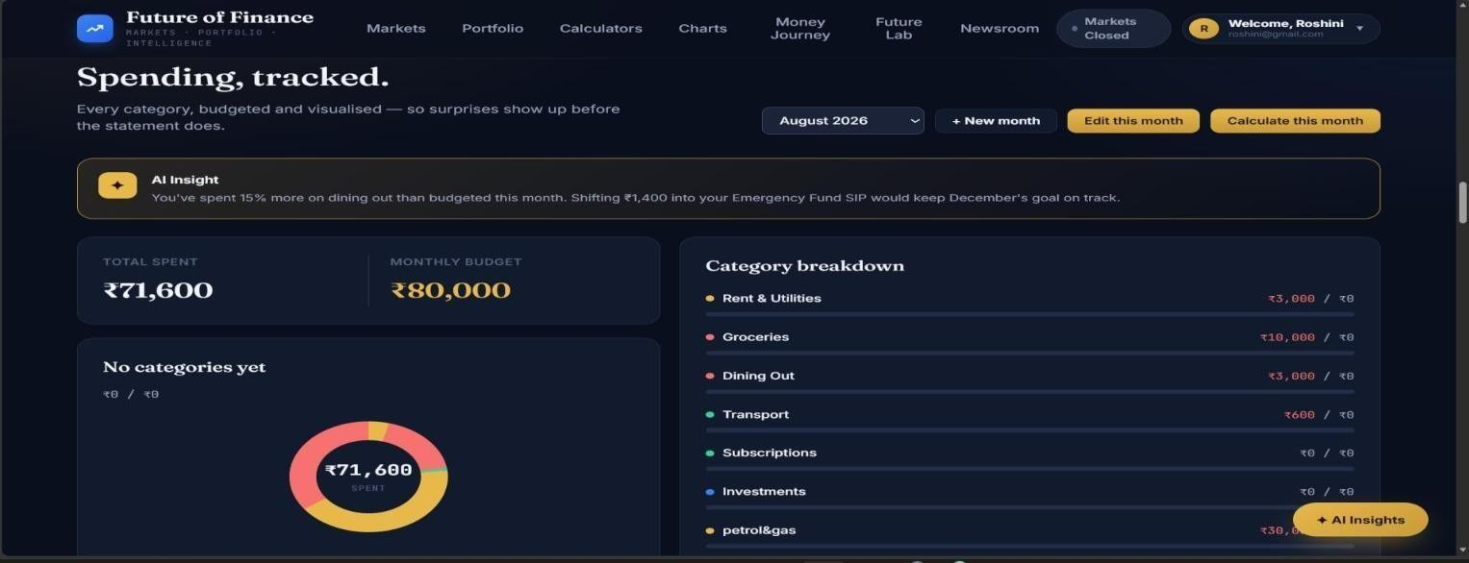

Fig. 5.4: Monthly Budget & Expense Tracking Dashboard

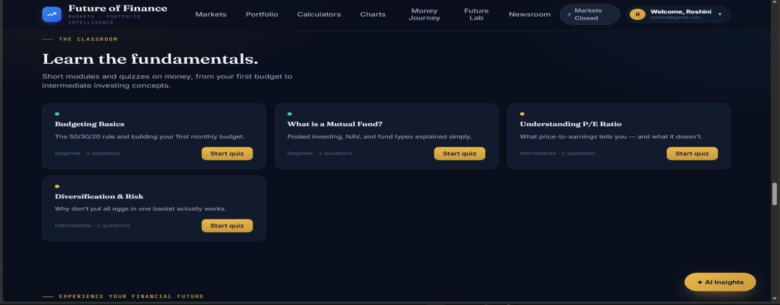

Fig. 5.5: Financial Learning & Interactive Quiz Module

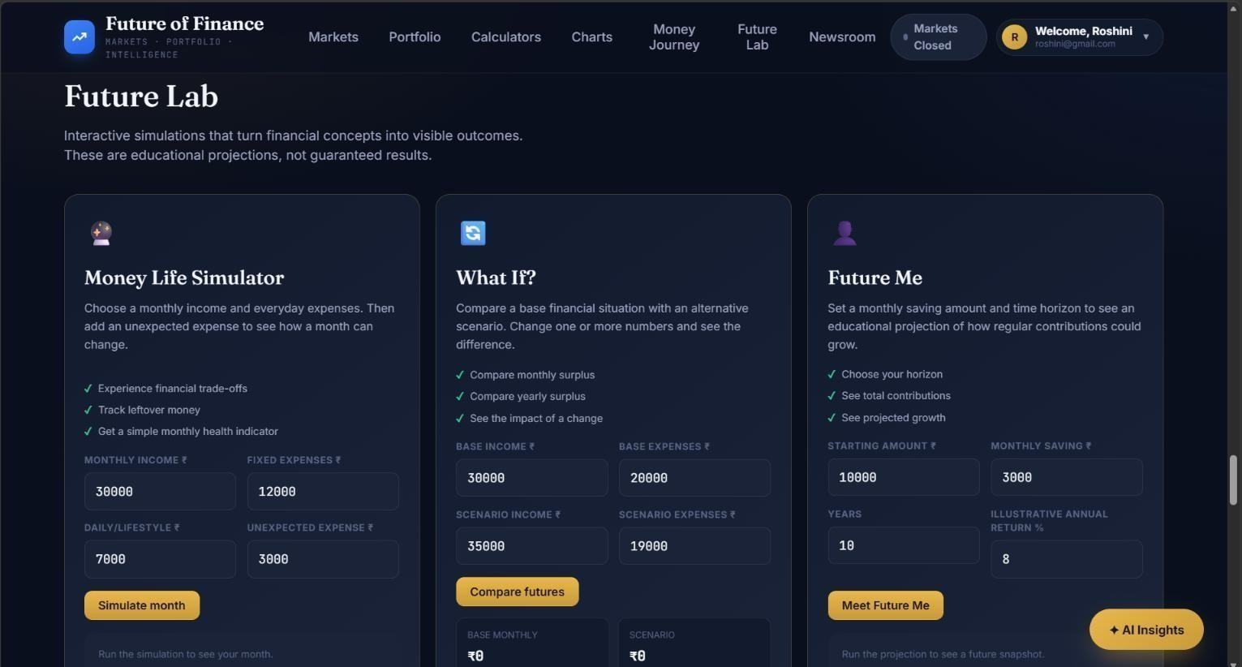

Fig. 5.6: Future Lab – Interactive Financial Simulation

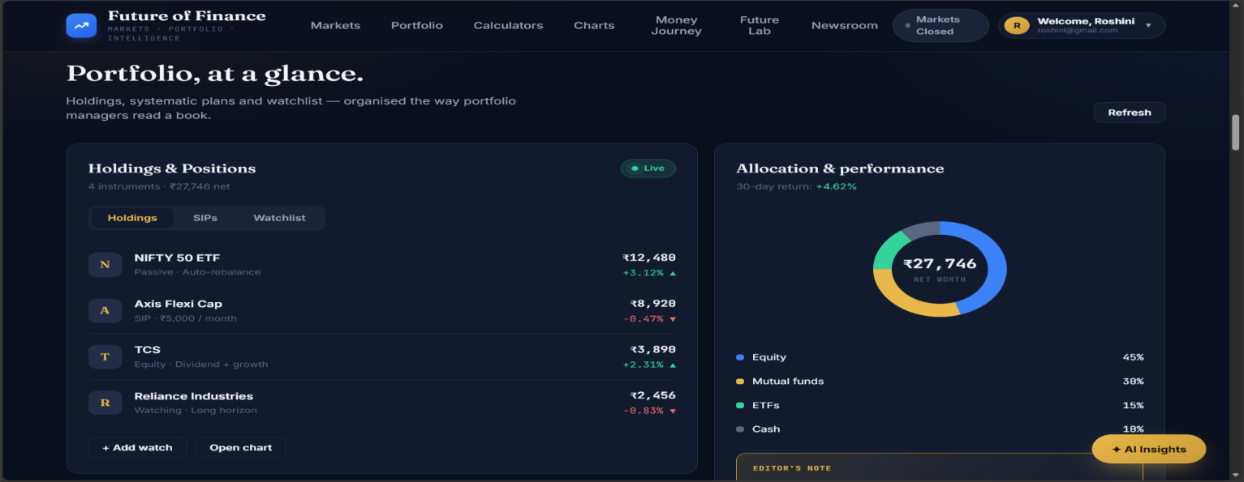

Fig. 5.7: Portfolio Management & Performance Dashboard

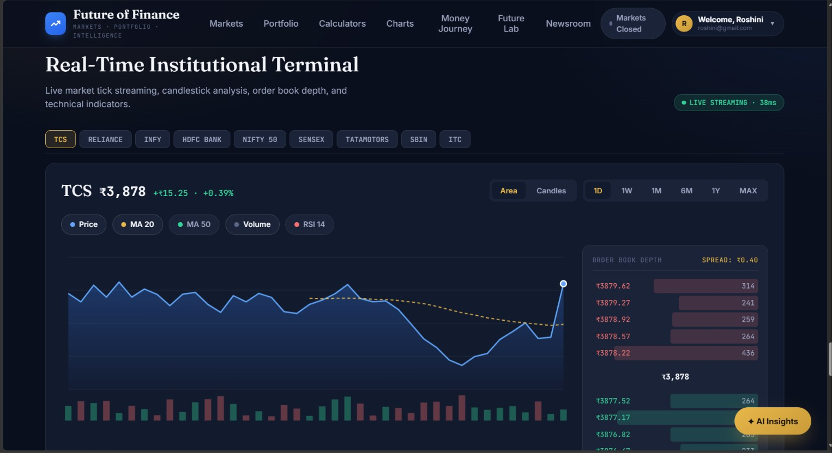

Fig. 5.8: Real-Time Institutional Market Analysis Dashboard

CHAPTER – 6

RESULTS & CONCLUSION

6.1 Results

The Future of Finance project successfully provides an integrated web-based platform for financial education and personal money management. The system brings together financial learning, income and expense tracking, monthly budgeting, financial calculators, market analysis, and financial news in a single interface. Interactive features such as AI Assistance, EMI Smart Planner, Money Life Simulator, What If Analysis, and Future Me provide users with opportunities to explore financial scenarios and understand different financial planning options.
The application presents financial information through organized dashboards, charts, and visual summaries, making financial concepts easier to understand. Overall, the project demonstrates how modern web technologies can support financial literacy, encourage responsible money management, and simplify financial planning. The extent to which each objective has been achieved is shown in Table 6.1.
Table 6.1 Objectives versus Outcomes

Objective | Outcome
Improve financial literacy | Interactive financial learning modules and quizzes are provided
Simplify personal money management | Income and expense tracking with monthly budgeting is available
Support informed financial decisions | Financial calculators, market analysis, financial news, and AI assistance are integrated
Help users visualize financial scenarios | EMI Smart Planner, Money Life Simulator, What If Analysis, and Future Me are implemented
Provide a single integrated platform | All modules are available in one web-based interface using  HTML, CSS, JavaScript, and Firebase

6.2 Conclusion

The Future of Finance project aims to bridge the gap between theoretical financial knowledge and practical money management by combining education, technology, and interactive financial tools. The platform provides users with a convenient way to learn financial concepts, monitor expenses, manage budgets, perform calculations, and explore financial scenarios.
Innovative features such as EMI Smart Planner, Money Life Simulator, What If Analysis, and Future Me make the platform more interactive and useful for understanding financial decisions. In conclusion, Future of Finance serves as a practical step toward improving financial awareness, promoting responsible spending and saving habits, and supporting better financial decision-making.

REFERENCES
- Mozilla Developer Network (MDN). (2024). HTML, CSS, and JavaScript Documentation. https://developer.mozilla.org/en-US/docs/Web
- Google. (2024). Firebase Documentation: Building Web Applications. https://firebase.google.com/docs
- W3Schools. (2024). Web Development Tutorials: HTML, CSS, and JavaScript. https://www.w3schools.com/
- National Centre for Financial Education (NCFE). Financial Literacy and Education Resources. https://ncfe.org.in/
- Securities and Exchange Board of India (SEBI). Investor Education and Financial Planning Resources. https://investor.sebi.gov.in/
- Investopedia. Personal Finance, Investment, and Financial Planning Resources. https://www.investopedia.com/
- National Stock Exchange of India (NSE). Investor Education and Financial Market Resources. https://www.nseindia.com/learn
- Google for Developers. AI and Web Application Development Documentation. https://developers.google.com/
- GeeksforGeeks. Web Technology, JavaScript, and Programming Tutorials. https://www.geeksforgeeks.org/
- Reserve Bank of India (RBI). Financial Education Resources. https://www.rbi.org.in/

